Tf- is a library that creates frame broadcast to publish and subscribe to the current frame, creates listener in order to listen to frames and track for changes, creates a structure (hirarchy tree) of frames.
Service-another way for nodes to communicate. It allows nodes to send a request and receive an answer. Rosservice can connect to a framework of server\client with services.its a one to many connection and it lasts for a long time.nUSE when need to remote procedure calls that terminate quickly (for querying the state of a node or doing a quick calculation such as IK). should never be used for longer running processes and should never change or depend on state to avoid unwanted side effects for other nodes. (blocking call)
Node- its a process that calculates, its an executable file within ros package. It uses a client library to communicate with another nodes. It can publish\subscribe to topic. It can also provide\use services
Topic- a way of communicating between nodes, one nodes publishes to topic while the other node subscribe to the same topic and in that way theyll communicate with each other. USE when need continues data (sensors data, robot state)
Action-its a server that doesnt have to be running and it waits to a reply.basiclly a type of server that execute long-running goals that can be precede. It also provides a client interface in order to send requests to the server. should always be implemented cleanly by action servers. Use for everything that moves the robot or that runs for a longer time such as perception routines that are triggered by some node and need a couple of seconds to terminate. (non-blocking background processing)

Robot moves and we need to wait to response
Short commands
finish quick topic
action
service
node
node
node

how to create an action:
1. cd catkin_sw\src
2. catkin_create_pgk package_name actionlib_msgs std_msgs
3. inside the new folder we just created, create a new folder named action
4. create an action file: file_name.action
(the general action file has three parts: the goal the result, and the feedback)
5. change the cmakelists (inside your new package):
check that inside find_package exist:actionlib_msgs,std_msgs
in order to create our action we need to add those functions (unmark them and change):
add_action_files(){
FILES
file_name.action (our new file instead of action1)
}

generated_messages(){
DEPENDENDIES
acrionlib_msgs
}

check that in the buildtool_depend there is:
<build_depend>actionlib_msgs</build_depend>
<build_depend>std_msgs</build_depend>
<run_depend> actionlib_msgs</run_depend>
<run_depend> std_msgs</run_depend>
6. cd . . into: catkin_ws and hit catkin_make
in order to see if it works lets create a node:
7. in our new folder create an src folder, create a new file in it:node.py
8. inside the new node file we want to use the new action-send goal,recieve a feedback..
so well import our msgs and see if it works:
from new_package_name.msgs import the nameofouractionGoal, nameofouractionResult, nameofouractionFeedback
print “blaa”
9. run the new node by:
rosrun name of our new package name of node.py
*if it prints so it worked

rqt_console
a plugin that provides logs from all nodes through connection to one node – rosout (solve the problem of connecting to all nodes from rqt to take the logs we need from each one). Can sort the priority of each and show\hide logs type and priority.
The rosout node : The job of rosout is to subscribe to /rosout topic , taking in log messages via direct connections to all nodes in the system, then republish those messages on an aggregation topic, /rosout_agg . The rosout node is started automatically for every ROS system as part of roscore . As a result, rosout is already up and running before any other node, and so can establish /rosout connections to other nodes as they are started. Later, when a tool like rqt_console starts, it need only make a single connection to the rosout node over the /rosout_agg topic, after which it will immediately begin receiving the aggregated log messages from all nodes in the system.

Rosbag:rosbag record subscribes to topics and writes a bag file with the contents of all messages published on those topics. The file contains interlaced, serialized ROS messages dumped directly to a single file as they come in over the wire
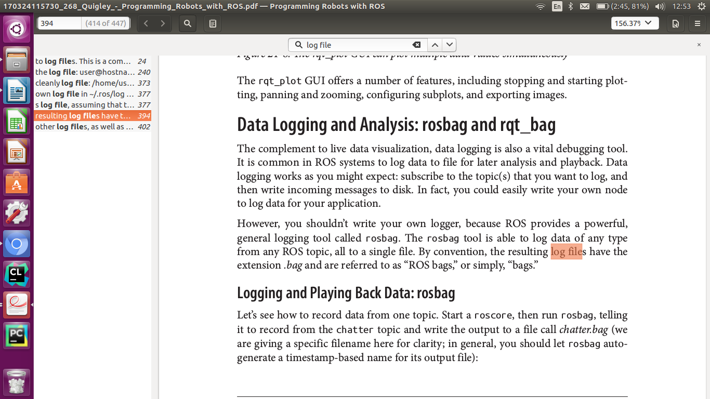
Rosbag can help debug nodes and save logs for them and then visualize the result in rviz. (how many topics were recorded and how frequentliy messages on each topic were received and also see the content of them).It can also help with loop the bag when testing processing piplines (over entire bag or part of it).
- Each node once it is up, crates a file log,
-

